For Rent

F1488 Villa Piña Way #201

2 bed 1.5 bath 900ft2

$1,550 per month

Spanish-style condo in great location

Won’t last! Availabl

e June 1

Contact Claire Vasquez @ (double-check cell #)

**ABOUT VILLA PIÑA**

Beautiful grounds Dine-in kitchen Spacious bedrooms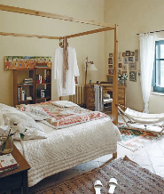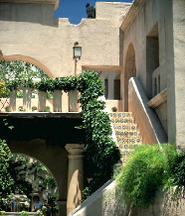

rivate but centrally Plocated, historic Villa Piña is just moments from [fine dining, shopping, and public transportation. Enjoy the best of both worlds at Villa Piña—the beauty of nature and the](https://pt.wikipedia.org/wiki/Neymar) culture of a vibrant neighborhood.

For more information, visit us online:

[*www.villapinacondos.com*](http://www.villapinacondos.com)

*←↑→↓↔五亝互互互亓ᐋ*